Lucas, Colin Anderson (1906-1984)

Colin Lucas was one of the few first generation of MODERN MOVEMENT architects in Britain who was English. His interest in a modern scientific approach to design is evident from the earliest reinforced concrete bungalow he designed for his parents in 1929 to his 1950s designs for the Roehampton Alton West Estate, as is his career-long passion for concrete. From 1934-39 he was a partner in Connell, Ward and Lucas, a firm that played a major part in the evolution of modern architecture in England. According to Arthur Korn they ‘introduced a new language into British architecture at a time when there were hardly any British architects thinking in an uncompromisingly contemporary vernacular.’ Lucas’ compositions were distinct. He used planes of four-inch thick concrete to explore the relationship of volume and skin with compositions underpinned by the regulating lines of the Golden Section. An advocate of LE CORBUSIER, Lucas very clearly strove for a functional solution. Form was something of beauty only if it was fit for its purpose. Of aesthetics he said, ‘I find arguments on aesthetics as meaningless as they are endless’.

Lucas was born on 29 December 1906 in Greenwich, London. He was the second son of the three children of Ralph Lucas (b.1876), a mechanical engineer and inventor, and his wife Mary, née Juler (1882-1952), a composer. He was educated at Cheltenham College from 1919 and at Trinity College, Cambridge where he studied at the School of Architecture (1925-28). Lucas had little exposure to modern architecture through a traditional education. His major early inspiration came from a creative home life and on leaving college he became manager of his father’s building firm Lucas, Lloyd & Co. In 1929 they constructed a family weekend house on the Thames at Bourne End. Known as Noah’s House, this was heralded as the first monolithic concrete house to be built in England.

In 1930 Lucas married Dione Wilson and his career progressed slowly in a tough economic climate with family commissions such as a weekend house for his grandfather and the fit-out of his wife’s cookery school, Le Petit Cordon Bleu, London. His own weekend house, The Hopfield was completed in 1933 in Kent and attracted more publicity. Seen as a modern architect, he was invited by WELLS COATES to join the avant-garde artist group Unit One, who sought to familiarise the British public with modern art. Lucas also became one of the first members of Coates’ MODERN ARCHITECTURE RESEARCH GROUP (MARS), an English branch of the CONGRÉS INTERNATIONAUX D’ARCHITECTURE MODERNE (CIAM).

In May 1934 Lucas joined two New Zealanders AMYAS CONNELL (1901-1980) and Basil Ward (1902-76) in practice. Together they experimented with techniques of monolithic reinforced concrete building. Lucas led a number of private house projects - Dragons in Sussex (1936), Greenside at Wentworth (1937, now demolished), Potcroft in Sutton (1937), 66 Frognal in Hampstead (1938) and 26 Bessborough Road in Roehampton (1939). In NIKOLAUS PEVSNER’s view Lucas’ houses were ‘often minor masterpieces’.
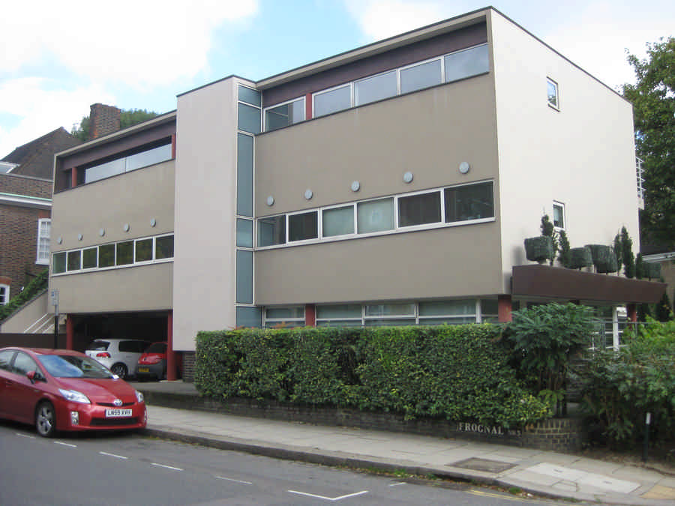
66 Frognal, Hampstead (1938).
http://www.e-architect.co.uk/images/jpgs/london/66_frognal_house_180911_aw2.jpg

After the practice disbanded in 1939 Lucas spent the war years assisting the British Research Station in the construction of defensive concrete structures. He rejoined his family on the other side of the Atlantic, where they had spent the war. When the couple decided to separate at the end of the 1940s, Lucas moved back to England and with the help of Leslie Martin (1909-2000), he joined the development section of the London County Council in the late 1940s, becoming one of the first members of the housing division in the architects’ department.

Lucas worked on the Ackroydon Estate in Wimbledon and later headed up the Alton West team on the Roehampton Estate, which won an RIBA bronze medal in 1959. Of Roehampton he said, ‘I think I learnt more about architecture and how to run jobs with that than in the rest of my career’. Staying with the LCC (latterly Greater London Council) until his retirement in 1978, he preferred to stay closely involved in the projects and mainly kept out of the public debate that followed his strong modern architectural output. Lucas was awarded an OBE in 1972. He had remarried in 1952 to Pamela Campbell.
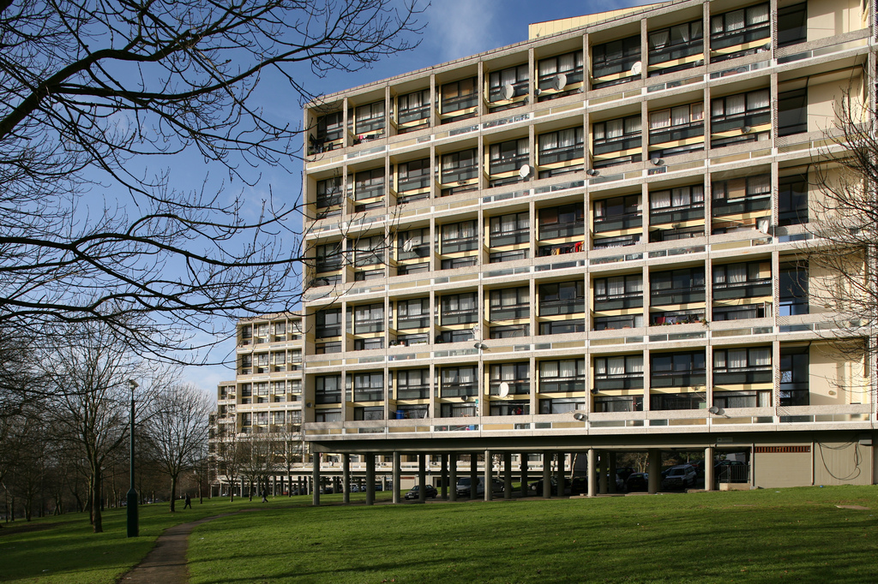
Alton West Estate, Roehampton, London (1951).
Copyright Steve Cadman.
http://www.flickr.com/photos/stevecadman/4282048947/sizes/l/

List of works

1929 Noah’s House, Bourne End, Buckinghamshire.

1933 The Hopfield, Wrotham, Kent.

1936 Dragons, Woodmancote, West Sussex.

1937 Bracken (Greenside), Wentworth, Virginia Water, Surrey.

1938 66 Frognal, Hampstead, London.

1951 Alton West Estate, Roehampton, London.

References and Further Reading

Dunnett, J. (1984) Obituary of Colin Lucas, Architects’ Journal: 52.

Lucas, M. (2002) ‘Colin Lucas, View of a creative life’, a memoir.

Read, H. ed. (1934) Unit One: The Modern Movement in English Architecture, Painting and Sculpture, London.

Rendel, S. and Sharp, D. (2008) Connell, Ward and Lucas, London: Frances Lincoln.

Sharp, D. (1994) Connell, Ward and Lucas: Modern Movement Architects in England, London, Book Art.

Stevens, T. (1956) ‘Connell, Ward and Lucas 1927-1939’, AA Journal: 112-15.
Anon., (1976) ‘Connell, Ward and Lucas’, Architect’s Journal: 467.

Anon., (1932) ‘A bungalow and boathouse at Bourne End, Bucks’, Architect and Building News: 223-27.

Korn, Arthur, Architectural Association Journal, November, 1956
Pevsner, Nikolaus, source unrecorded
Quoted from a conversation with Dunnett, James, Architect’s Journal, 9 May 1984, p.28

